**Distress:**

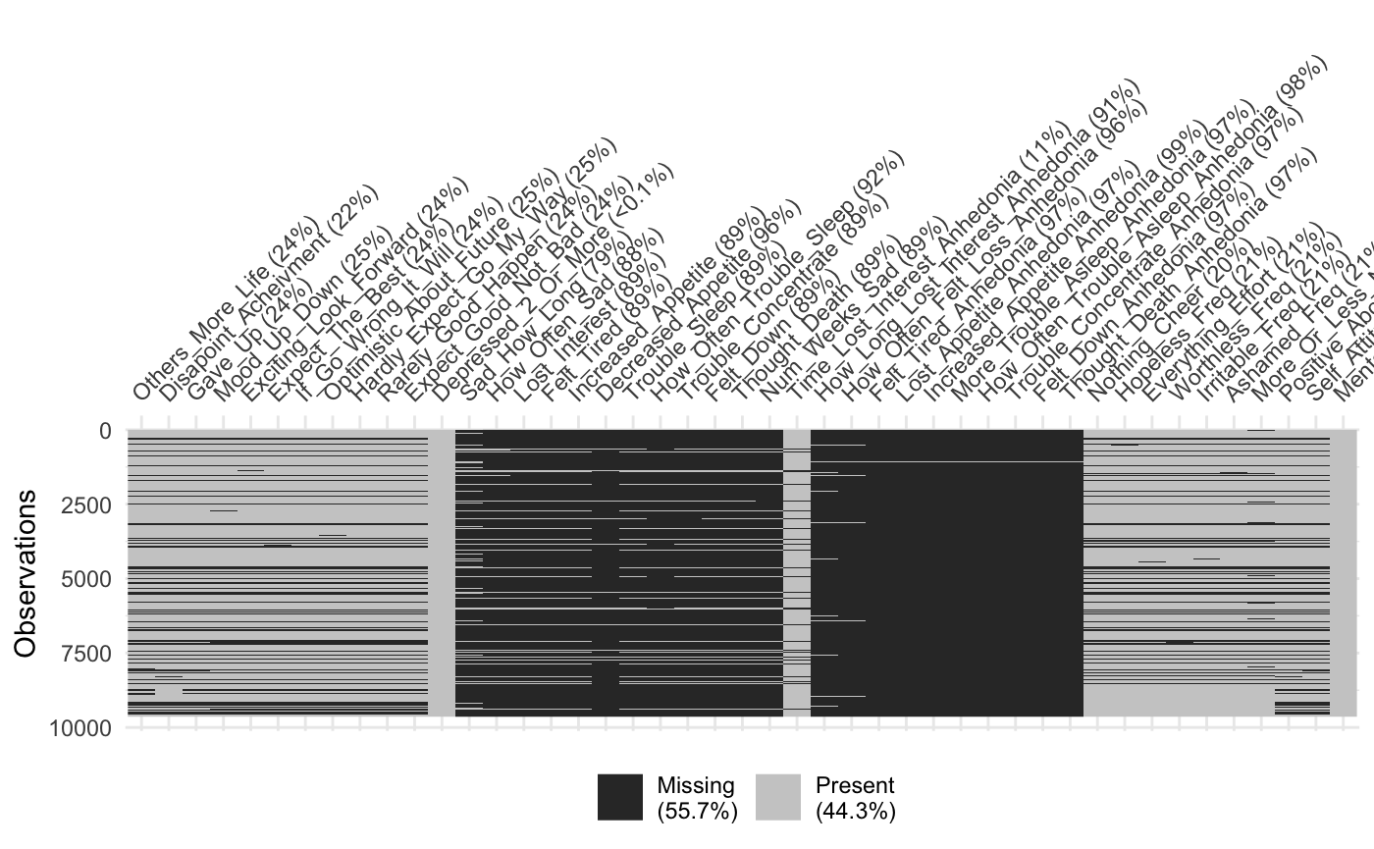

**Others_More_Life** - Most of the missingness is due to missing SAQ data (~ 20% across the samples)

**Disappoint_Achievement** - Most of the missingness is due to missing SAQ data (~ 20% across the samples)

**Gave_Up** - Most of the missingness is due to missing SAQ data (~ 20% across the samples)

**Mood_Up_Down** - Most of the missingness is due to missing SAQ data (~ 20% across the samples)

**Exciting_Look_Forward** - Most of the missingness is due to missing SAQ data (~ 20% across the samples)

**Expect_The_Best** - Most of the missingness is due to missing SAQ data (~ 20% across the samples)

**If_Go_Wrong_It_Will** - Most of the missingness is due to missing SAQ data (~ 20% across the samples)

**Optimistic_About_Future** - Most of the missingness is due to missing SAQ data (~ 20% across the samples)

**Hardly_Expect_Go_My_Way** - Most of the missingness is due to missing SAQ data (~ 20% across the samples)

**Rarely_Good_Happen** - Most of the missingness is due to missing SAQ data (~ 20% across the samples)

**Expect_Good_Not_Bad** - Most of the missingness is due to missing SAQ data (~ 20% across the samples)

**Depressed_2_Or_More** - Very little missingness, however, this starts the skip pattern for all depression items. If the response option chosen was less than 2 weeks, they are skipped for all depression items to question PA72. The following are included in the Depressed_Affect_Composite:

**Sad_How_Long** - Missing 80% as they were skipped

**How_Often_Sad** - Missed 88% because those who were sad less than half the day in the two week period were skipped.

**Lost_Interest** - 89% Missing because of previous skip pattern.

**Felt_Tired** - 97% missing because of pervious skip pattern

**Lost Appetite** - 97%because of the same skip pattern.

**Increased Appetite** - 97% because if they said yes to lost appetite, they did not receive this item.

**Trouble_Sleep** - 89% missing because of the same skip pattern as Lost_Interest

**How_Often_Trouble_Sleep** - Missing 92% because only those who responded yes to trouble sleeping got this item.

**Trouble_Concentrate** - 89% missing because of the same skip pattern as Lost_interest.

**Felt_Down** - 89% Missing because of the same skip pattern as Lost_Interest

**Thought_Death** - 89% missing because of the same skip pattern as Lost_Interest.

**Num_Weeks_Sad** - 89% missing because of the same skip pattern as Lost_Interest.

The missingness from Depressed_2_Or_More is corrected by creating the composite, Depressed_Affect, which averages across items between Depressed_2_Or_More and Num_Weeks_Sad. This composite is provided by MIDUS, please see the MIDUS items spreadsheet to determine how to combine this item across data sets.

**Time_Lost_Interest_Anhedonia** - Here the skip pattern restarts for the anhedonia composite and we only ask people the following questions if they have lost interest for two or more weeks in the last year:

**How_Long_Lost_Interest_Anhedonia** - 91% missing because of skip pattern.

**How_Often_Felt_Loss_Anhedonia** - 96% missing because of skip pattern.

**Felt_Tired_Anhedonia** - 97% missing because of skip pattern.

**Lost_Appetite_Anhedonia** - 97% missing because of skip pattern.

**Increased_Appetite_Anhedonia** - 99% missing because those who reported loss of appetite were not given this question.

**More_Trouble_Asleep_Anhedonia** - 97% missing, same skip pattern as Lost_Appetite.

**How_Often_Trouble_Asleep_Anhedonia** - 98% missing as only those who reported trouble sleeping got this item.

**Trouble_Concentrate_Anhedonia** - 97% missing, same skip pattern as Lost_Appetite.

**Felt_Down_Anhedonia** - 97% missing, same skip pattern as Lost_Appetite.

**Thought_Death_Anhedonia** - 97% missing, same skip pattern as Lost_Appetite

The extreme missingness for the anhedonia items was corrected by creating an anhedonia composite. This composite is provided by MIDUS, please see the MIDUS items spreadsheet to determine how to combine this item across data sets. All indented items following Time_Lost_Interest_Anhedonia are included in the composite.

**Nothing_Cheer** - Missing about 20% due to missing SAQ data.

**Hopeless_Freq** - Missing about 20% due to missing SAQ data.

**Everything_Effort** - Missing about 20% due to missing SAQ data.

**Worthless_Freq** - Missing about 20% due to missing SAQ data.

**Irritable_Freq** - Missing about 20% due to missing SAQ data.

**Ashamed_Freq** - Missing about 20% due to missing SAQ data.

**More_Or_Less_Negative** - Missing about 20% due to missing SAQ data.

**Mental_Emotional** - Very little missing data because it was asked in the interview!

**Fear:**

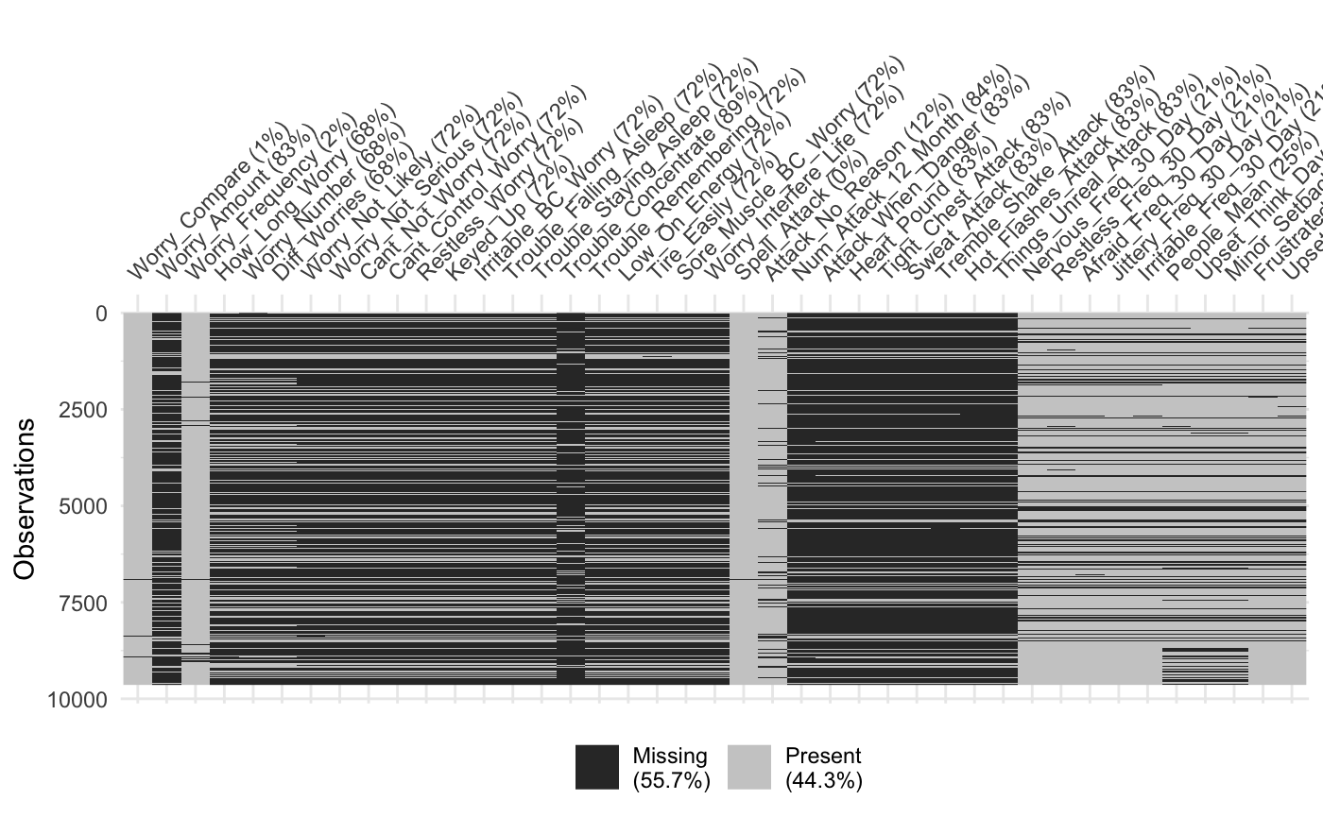

**Worry_Compare** - This was an interviewer administered question so missing data is only 1%!

**Worry_Amount** - Missing data 83% because only those who said they worry more than others received this question.

**Worry_Frequency** - This was an interviewer administered question so missing data is only 2%!

**How_Long_Worry** - Those who worried less than half the days in the previous question were skipped so we have 68% missing.

**Worry_Number** - Those who worried less than half the days in the previous question were skipped so we have 68% missing.

**Diff_Worries** - Those who worried less than half the days in the previous question were skipped so we have 68% missing.

**Worry_Not_Likely** - People only received this item if they worried about more than one thing and worried about things not likely to happen so missing is (72%)

**Worry_Not_Serious** - People only received this item if they worried about more than one thing and worried about things not likely to happen so missing is (72%)

**Cant_Not_Worry** - People only received this item if they worried about more than one thing and worried about things not likely to happen so missing is (72%)

**Cant_Control_Worry** - People only received this item if they worried about more than one thing and worried about things not likely to happen so missing is (72%)

**Restless_Worry** - People only received this item if they worried about more than one thing and worried about things not likely to happen so missing is (72%)

**Keyed_Up** - People only received this item if they worried about more than one thing and worried about things not likely to happen so missing is (72%)

**Irritable_BC_Worry** - People only received this item if they worried about more than one thing and worried about things not likely to happen so missing is (72%)

**Trouble_Falling_Asleep** - People only received this item if they worried about more than one thing and worried about things not likely to happen so missing is (72%)

**Trouble_Staying_Asleep** - People only received this item if they worried about more than one thing and worried about things not likely to happen so missing is (72%)

**Trouble_Concentrate** - People only received this item if they worried about more than one thing and worried about things not likely to happen so missing is (72%)

**Trouble_Remembering** - People only received this item if they worried about more than one thing and worried about things not likely to happen so missing is (72%)

**Low_On_Energy** - People only received this item if they worried about more than one thing and worried about things not likely to happen so missing is (72%)

**Tire_Easily** - People only received this item if they worried about more than one thing and worried about things not likely to happen so missing is (72%)

**Sore_Muscle_BC_Worry** - People only received this item if they worried about more than one thing and worried about things not likely to happen so missing is (72%)

**Worry_Interfere_Life** - People only received this item if they worried about more than one thing and worried about things not likely to happen so missing is (72%)

**Spell_Attack** - This was an interviewer administered question so missing data is only 0%!

**Attack_No_Reason** - The skip pattern doesn't match their description here and it appears most people got this question so we have a missing rate of 12%

**Num_Attack_12_Month** - Only those who responded yes to having attacks received this question so we are sitting at 84% missing.

**Attack_When_Danger** - Only those who responded yes to having attacks received this question so we are sitting at 83% missing.

**Heart_Pound** - Only those who responded yes to having attacks received this question so we are sitting at 83% missing.

**Tight_Chest_Attack** - Only those who responded yes to having attacks received this question so we are sitting at 83% missing.

**Sweat_Attack** - Only those who responded yes to having attacks received this question so we are sitting at 83% missing.

**Tremble_Shake_Attack** - Only those who responded yes to having attacks received this question so we are sitting at 83% missing.

**Hot_Flashes_Attack** - Only those who responded yes to having attacks received this question so we are sitting at 83% missing.

**Things_Unreal_Attack** - Only those who responded yes to having attacks received this question so we are sitting at 83% missing.

**Nervous_Freq_30_Day** - This is self rated health so the only missing data is for those with missing SAQ data, so we are sitting at roughly 20% missing data here.

**Restless_Freq_30_Day** - This is self rated health so the only missing data is for those with missing SAQ data, so we are sitting at roughly 20% missing data here.

**Afraid_Freq_30_Day** - This is self rated health so the only missing data is for those with missing SAQ data, so we are sitting at roughly 20% missing data here.

**Jittery_Freq_30_Day** - This is self rated health so the only missing data is for those with missing SAQ data, so we are sitting at roughly 20% missing data here.

**Irritable_Freq_30_Day** - This is self rated health so the only missing data is for those with missing SAQ data, so we are sitting at roughly 20% missing data here.

**People_Mean** - This is self rated health so the only missing data is for those with missing SAQ data, so we are sitting at roughly 20% missing data here.

**Upset_Think_Day** - This is self rated health so the only missing data is for those with missing SAQ data, so we are sitting at roughly 20% missing data here.

**Minor_Setback_Irritate** - This is self rated health so the only missing data is for those with missing SAQ data, so we are sitting at roughly 20% missing data here.

**Frustrated_Freq_30_Day** - This is self rated health so the only missing data is for those with missing SAQ data, so we are sitting at roughly 20% missing data here.

**Upset_Freq_30_Day** - This is self rated health so the only missing data is for those with missing SAQ data, so we are sitting at roughly 20% missing data here.

**Substance use:**

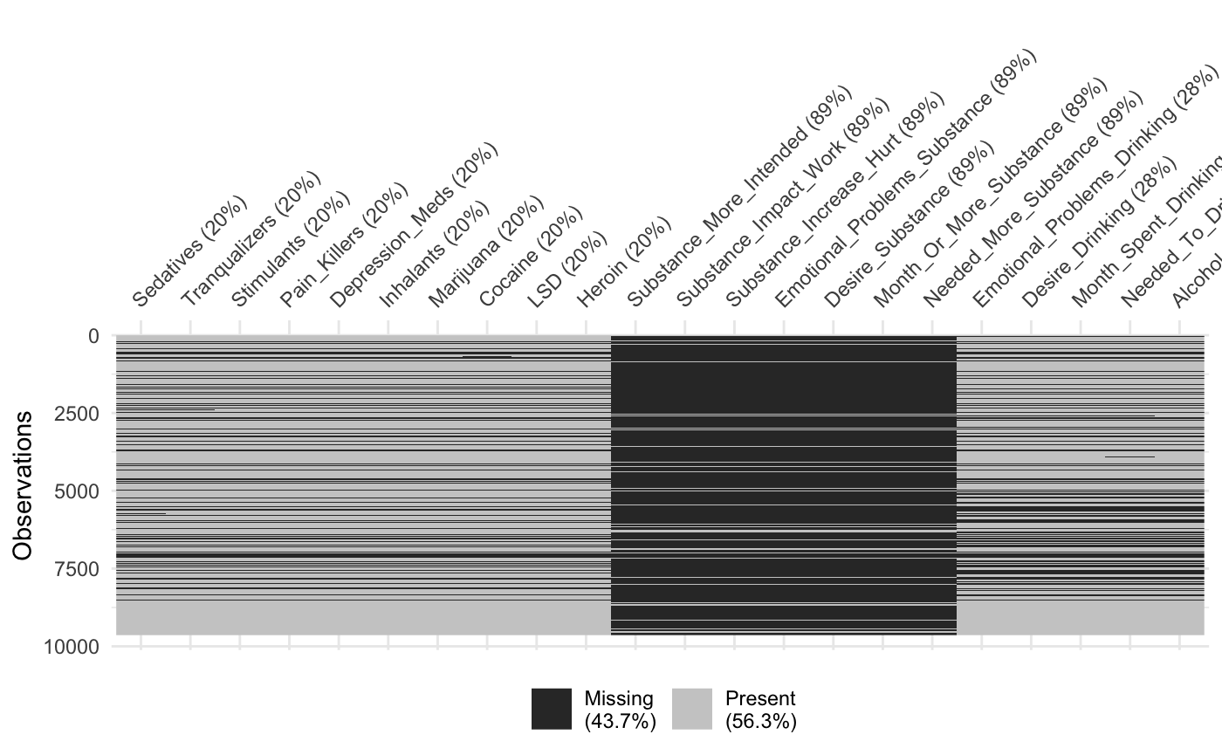

**Sedatives** - Around 20% is missing for these items as those who did not complete the self administered questionnaire did not complete these items.

**Tranquilizers** - Around 20% is missing for these items as those who did not complete the self administered questionnaire did not complete these items.

**Stimulants** - Around 20% is missing for these items as those who did not complete the self administered questionnaire did not complete these items.

**Pain Killers** - Around 20% is missing for these items as those who did not complete the self administered questionnaire did not complete these items.

**Depression_Meds** - Around 20% is missing for these items as those who did not complete the self administered questionnaire did not complete these items.

**Inhalants** - Around 20% is missing for these items as those who did not complete the self administered questionnaire did not complete these items.

**Marijuana** - Around 20% is missing for these items as those who did not complete the self administered questionnaire did not complete these items.

**Cocaine** - Around 20% is missing for these items as those who did not complete the self administered questionnaire did not complete these items.

**LSD** - Around 20% is missing for these items as those who did not complete the self administered questionnaire did not complete these items.

**Heroin** - Around 20% is missing for these items as those who did not complete the self administered questionnaire did not complete these items.

**Substance_More_Intended** - Only those who reported at least one substance received this item yielding missing values of 89%.

**Substance_Impact_Work** - Only those who reported at least one substance received this item yielding missing values of 89%.

**Substance_Increase_Hurt** - Only those who reported at least one substance received this item yielding missing values of 89%.

**Emotional_Problems_Substance** - Only those who reported at least one substance received this item yielding missing values of 89%.

**Desire_Substance** - Only those who reported at least one substance received this item yielding missing values of 89%.

**Month_Or_More_Substance** - Only those who reported at least one substance received this item yielding missing values of 89%.

**Needed_More_Substance** - Only those who reported at least one substance received this item yielding missing values of 89%.

**Emotional_Problems_Drinking** - Around 20% is missing for these items as those who did not complete the self administered questionnaire did not complete these items.

**Desire_Drinking** - Around 20% is missing for these items as those who did not complete the self administered questionnaire did not complete these items.

**Month_Spent_Drinking** - Around 20% is missing for these items as those who did not complete the self administered questionnaire did not complete these items.

**Needed_To_Drink_More** - Around 20% is missing for these items as those who did not complete the self administered questionnaire did not complete these items.

**Alcohol_More_Thank_Intended** - Around 20% is missing for these items as those who did not complete the self administered questionnaire did not complete these items.

**Alcohol_Affected_Work** - Around 20% is missing for these items as those who did not complete the self administered questionnaire did not complete these items.

**Miscellaneous disinhibited:**

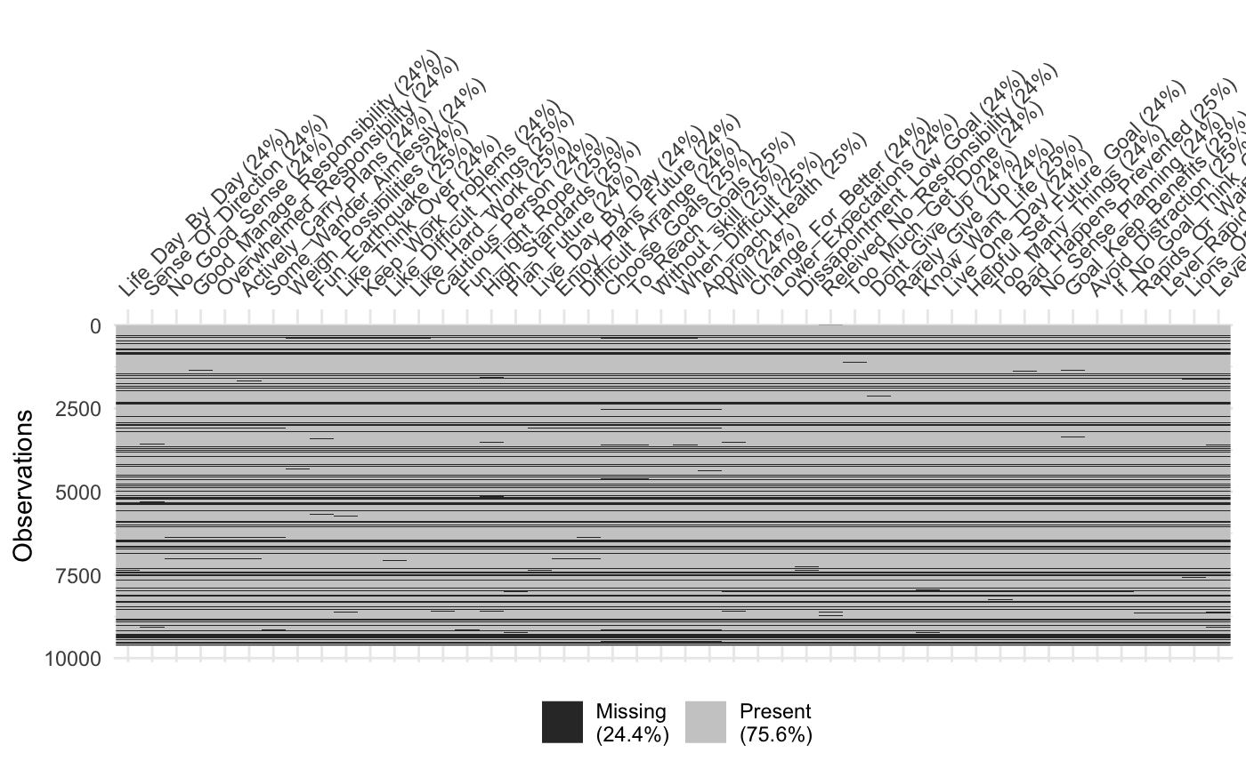

All missing values for these items are due to missing SAQ data, which is good for us as we don't have to worry about skip patterns here! This should be handleable with simply removing those without SAQ data.

**Antagonistic Externalizing:**

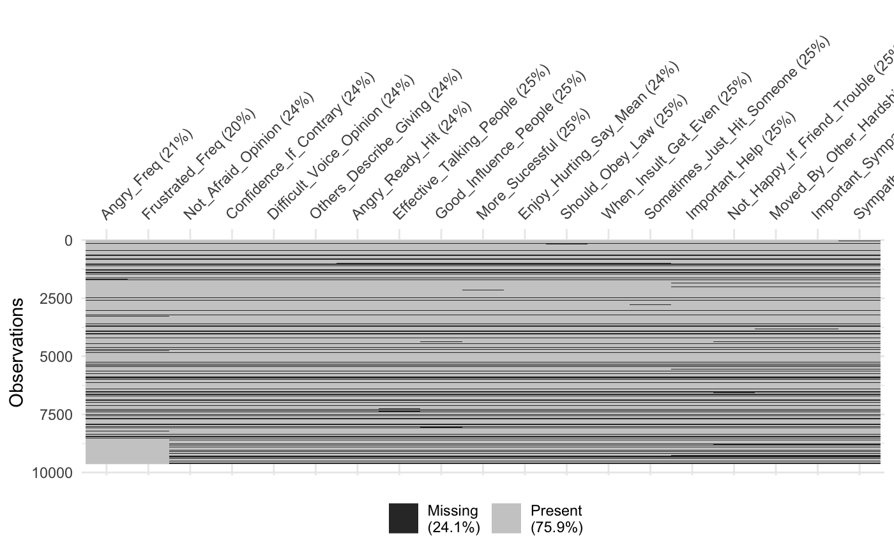

All missing values for these items are due to missing SAQ data, which is good for us as we don't have to worry about skip patterns here! This should be handleable with simply removing those without SAQ data.

**Detachment:**

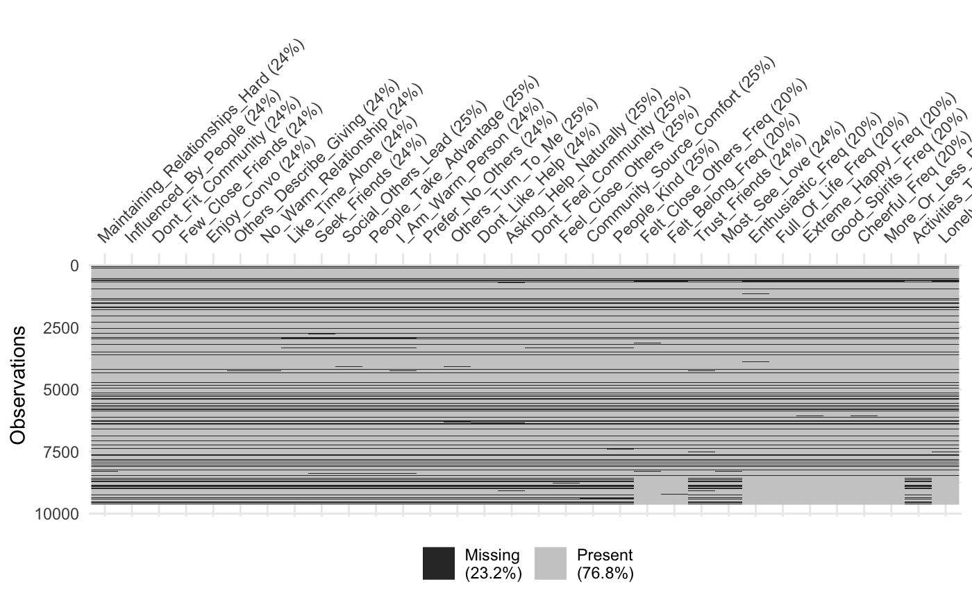

All missing values for these items are due to missing SAQ data, which is good for us as we don't have to worry about skip patterns here! This should be handleable with simply removing those without SAQ data.

**Somaticizing:**

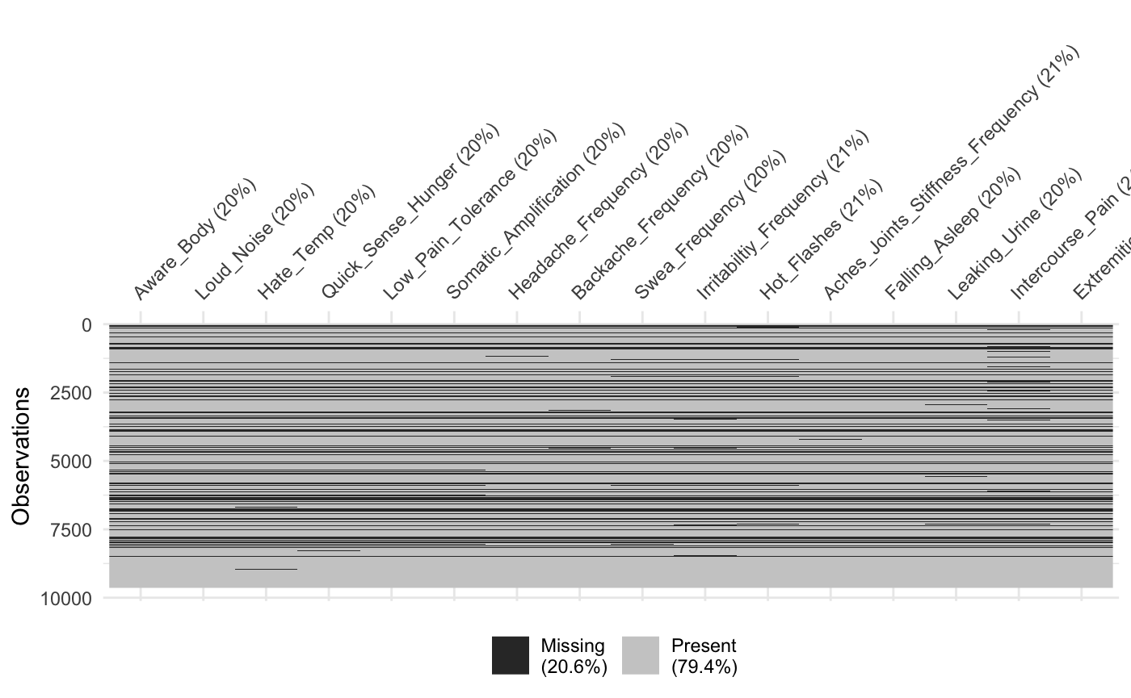

All missing values for these items are due to missing SAQ data, which is good for us as we don't have to worry about skip patterns here! This should be handleable with simply removing those without SAQ data.